To be completed by CELTA candidate

Submitted by: Steven Levithan

Assignment title: Focus on the Learner (FOL)

Assignment number: 1

Number of words: 976

Submitted on (date): 2020-12-07

This assignment is my original work and I have acknowledged all sources.

Full name: Steven Levithan

To be completed by CELTA tutor

Overall grade:

General comments:

Focus on the Learner Assignment

Learner Profile
Angelica is a 59-year-old intermediate (B1) Mexican student. Her L1 is Spanish and she was born and raised in Mexico City, where she continues to live. Her English background is that she took a couple courses about 40 years ago while in university (where she studied Mathematics), and early in her career she studied English for about four years. Until last year, she worked as an IT project manager at a bank.

Earlier in life, Angelica’s motivations for learning English were extrinsic, related to her university studies and work. However, she now says, “At this time of my life, [it’s] just for enjoyment”. Now that she’s out of work and a year away from retirement, she’s driven by intrinsic motivation. She loves learning generally, and learning English provides her with a feeling of accomplishment. “Intrinsic motivation is described as ‘passion for learning’ [...] Students who are intrinsically motivated are driven by a desire to succeed in class and by what happens in the lesson.” (Harmer 2015: 90) Although her study isn’t driven by goals, she loves travel and hopes to use her improved English while traveling, since she enjoys talking to people overseas and attending cultural events.

Her learning styles are mainly visual and interpersonal. She enjoys speaking with and learning from other students, and uses their mistakes to improve her own understanding. She prefers a live classroom over virtual in order to pick up on more nuanced non-verbal communication from the teacher and because she can see all material and people simultaneously.

When asked about activities she likes best and least in class, she mentioned she enjoys practice, especially through speaking. She said there were no activities she doesn’t like, and that she gains something from every kind of activity. For focusing on accuracy, she likes solo activities.

Language Problems
Angelica’s strengths include speaking with fluency and a broad lexis. She spoke confidently during our interview and I never had trouble understanding what she was expressing. During class, I noticed she gets lots of speaking practice because she’s motivated to speak and not afraid of her mistakes. She also has a wide vocabulary and can speak competently on a variety of topics, including the workplace, travel, cultural activities, etc. However, she has room to improve the sophistication and depth of her lexis.

Angelica’s weaknesses include listening for detailed understanding, pronunciation, and grammar. Although she had no problem understanding when I spoke slowly and in short sentences during our interview, she had trouble catching details when I used more natural connected speech, or when my questions were longer. She also frequently had trouble with pronunciation of multi-syllabic words when the stress should be on the first syllable, as a result of L1 interference. “In Spanish [...] penultimate stress is predominant (in 75% to 80% of the words, the syllable marked for primary stress is the second-to-last syllable) [...] For a Spanish speaker then, it is very likely that the preferred stressed syllable in a trisyllabic stimulus would mark the middle section of the word, and not one of its boundaries.” (Toro-Soto et. al. 2007: 169) She also displayed a variety of grammar errors including choosing the wrong verb tenses, confusing first and third person verb forms, and not knowing when to use verbs in -ing form. Although I believe she is likely to be generally aware of the related grammar rules, she didn’t show awareness of making mistakes during conversation given that she rarely stopped to correct herself.

Suggested Activities
Pronunciation
Angelica has trouble with word stress. The following errors were observed in her speaking:

foreigners: /fɔrˈeɪnərz/ instead of /ˈfɔrənərz/
theater: /θiˈætər/ instead of /ˈθiətər/
spectacle: /spɛkˈtækəl/ instead of /ˈspɛktəkəl/

I chose this problem because, although Angelica’s pronunciation is reasonable for her level, she needs to improve her pronunciation to feel more confident with her speaking and be more clearly understood by native speakers during her travels. “Concentrating on sounds […and] making [students] aware of where stress falls in words and phrases and how intonation works – all these things give extra information about spoken English and help the students achieve the goal of improved comprehension and intelligibility.” (Harmer 2015: 277)

To address the issue, I selected an intermediate level activity (appendix 1) that will help show that stress falls on different syllables in English words. I would modify this exercise to include words Angelica mispronounced.

Grammar
Angelica has trouble using the past simple tense correctly. The following errors were observed in her speaking:

“I like it” [speaking about the past]
“It was nice because I work in different kind[s] of project[s] involving different areas”
“I was lay off last year”
“Last year I start to enjoying […]”

Although this problem won’t always cause difficulties with understanding since the time reference can often be understood from context, I’m focusing on this because it’s important to handle correctly at her level. Without intervention, the problem may fossilize and cause confusion for her listeners.

I’ve selected an intermediate level activity (appendix 2) where Angelica will need to identify incorrect uses of present simple tense in a text about traveling from Mexico to Canada for vacation, and convert the verbs to past simple. I expect her to find this task engaging because of her love of travel. “One of the keys to sustaining student motivation is to make the materials and activities we are using relevant to our students’ lives and interests.” (Harmer 2015: 93) I expect the practice to be meaningful because it is a realistic story about travel experiences, which is a natural context in which to use past simple verbs. The activity could be modified in a classroom to include a follow-up speaking task where students tell their own travel stories using past simple verbs. This would play to Angelica’s enjoyment of speaking practice and her interpersonal learning style.

Bibliography & References
- J. Harmer, The Practice of English Language Teaching, 5th Edition, Pearson, 2015
- J. M. Toro-Soto, A. Rodríguez-Fornells & N. Sebastián-Gallés, Stress placement and word segmentation by Spanish speakers, Psicológica, 2007
- M. Hancock, English Pronunciation in Use, Cambridge University Press, 2003
- R. Dobie, All Things Grammar [website], Editing Practice: Past Simple, <https://www.allthingsgrammar.com/uploads/2/3/2/9/23290220/atg-edit-pastsimpler.pdf>
- Cambridge Learner’s Dictionary [website], <https://dictionary.cambridge.org/dictionary/learner-english/>

Appendix 1: Pronunciation Activity
Pronunciation exercise from English Pronunciation in Use by Mark Hancock, pp. 68-69.
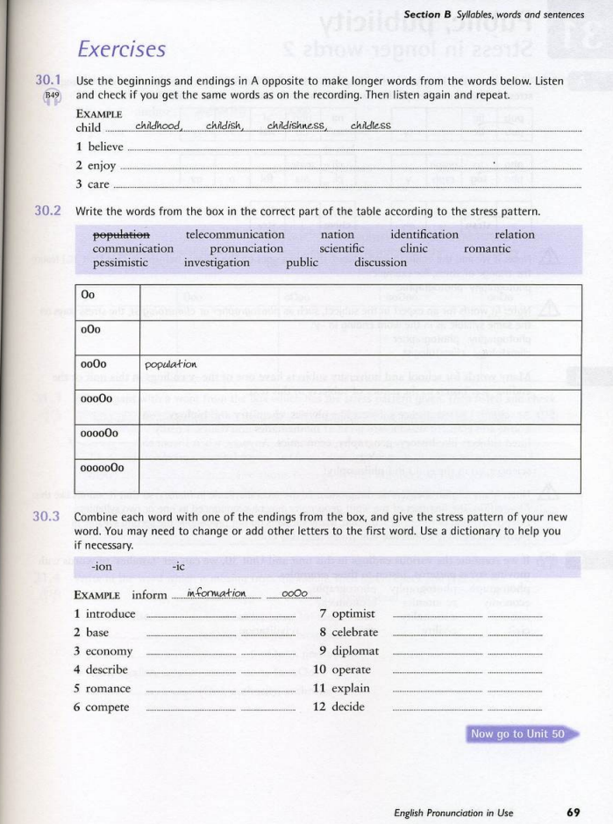
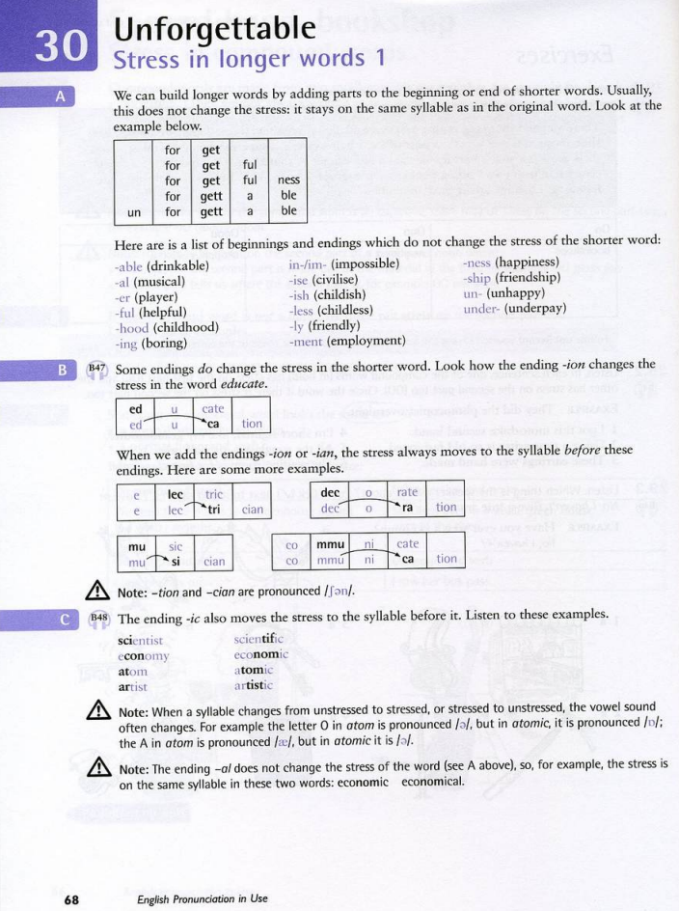

Appendix 2: Grammar Activity
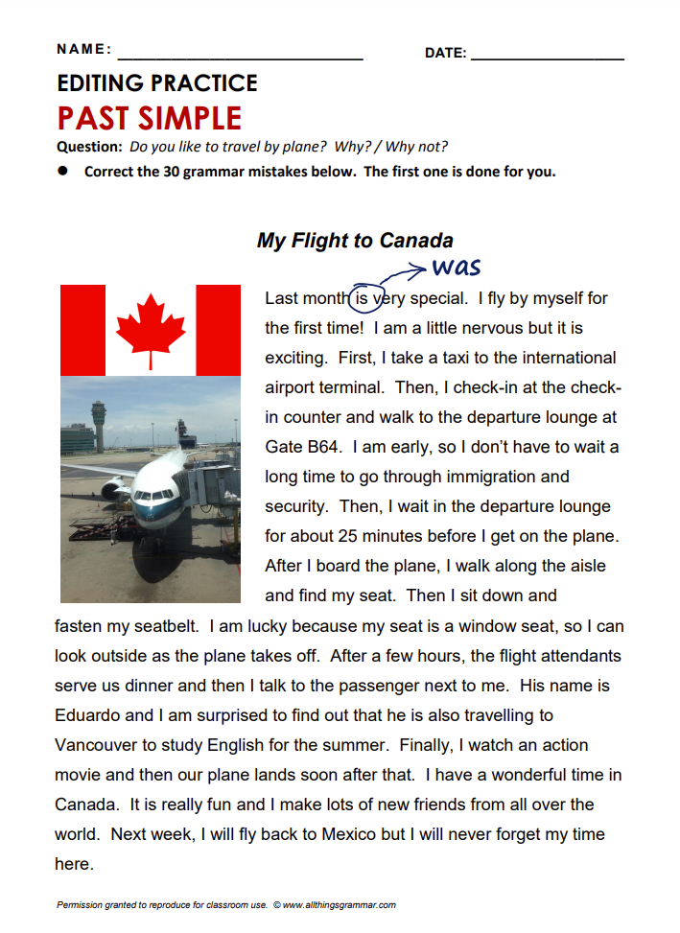
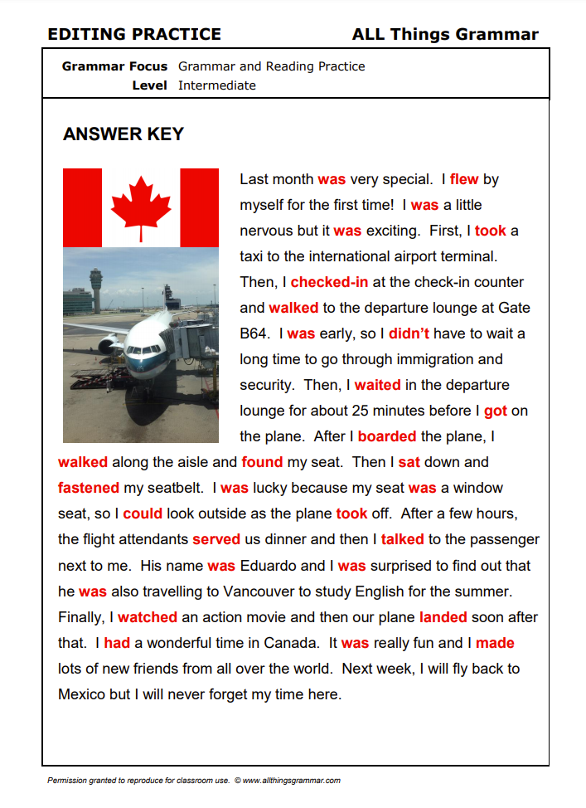
Grammar exercise from All Things Grammar by Robert Dobie, at <https://www.allthingsgrammar.com/uploads/2/3/2/9/23290220/atg-edit-pastsimpler.pdf>

